Nama : Aditia Surya Putra

Kelas : Flutter D

Source Code :

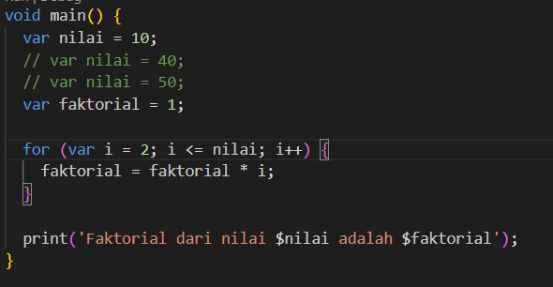

|  |  |
| --- | --- |
| **Input** | **Output** |
|  |  |
|  |  |
|  |  |